COUNTRY LEVEL COMMUNITY CORRECTIONS DATA SUMMARY
Country | Latvia
Ministry responsible | Ministry of Justice
Community corrections administration (denote if separate from prison) | State Probation Service (SPS) / Valsts probācijas dienests
Contact address | Valērijas Seiles str. 9-1, Rīga, LV-1019
Telephone | +371 28613531
Fax | --
Email | pasts@vpd.gov.lv
Website | https://www.vpd.gov.lv
Head of community corrections administration (and title) | Imants Jurevičius, Head of the State Probation Service of Latvia
Community corrections population total | 5 111
Community corrections rate (offenders per 100,000 of national population) | 273,0
Females in community corrections | 756 (14,8 %)
Juveniles / minors / young individuals in community corrections | 100 (2,0 %)
Foreign individuals in community corrections | 91 (1,8 %)
Types of community-based, non-custodial sanctions (listed) | - Forms of Probation before the sentence:  - Conditional suspension of the criminal proceedings with probation supervision  - Educational correctional measures for children (special form of community supervision of children (11 years+))  - Forms of Probation after the sentence:  - Fully suspended custodial sentence with probation supervision  - Community service  - Probation supervision  - Mixed sanctions (2.1+2.2.; 2.2. + 2.3.)  - Forms of Probation after release from custody:  - Conditional release (parole) with probation supervision  - Conditional release (parole) with probation supervision and electronic monitoring  - Probation supervision as additional punishment
Proportion of probation clients placed under probation before the sentence | Total (percentage): 235 persons (4,6%)  Of which:  - Conditional suspension of the criminal proceedings with probation supervision by the decision of the prosecutor: 112 (47,7%)  - Victim-offender mediation: 111 (47,2%)  - Educational correctional measures for children (Community service or Probation Observation): 12 (5,1%)  - Pre-trial assessment reports: A total of 805 requests were received to evaluate the most appropriate sentence or educational measures for the individuals.
Proportion of probation clients placed under probation after the sentence | Total (percentage): 4773 (93,4%)  Of which:  - Fully suspended custodial sentence with probation supervision: 1529 (32,1%)  - Community service: 2421 (50,7%)  - Probation supervision: 556 (11,6%)  - Mixed sanctions (Community service and Probation supervision or Fully suspended custodial sentence with probation and Community Service): 267 (5,6%)
Proportion of probation clients placed under probation after release from custody | Total (percentage): 103 (2%)  Of which:  - Conditional release (parole) with probation supervision 72 (69%)  - Conditional release (parole) with probation supervision and electronic monitoring 31 (30,1%)
Community corrections trend (year, community corrections population total, rate = total community corrections population per 100,000 persons) |  | 2020 | 5 673 | 297,4
 |  | 2021 | 5 594 | 295,5
 |  | 2022 | 5 767 | 311,9
 |  | 2023 | 5 451 | 289,5
 |  | 2024 | 5 111 | 273,0

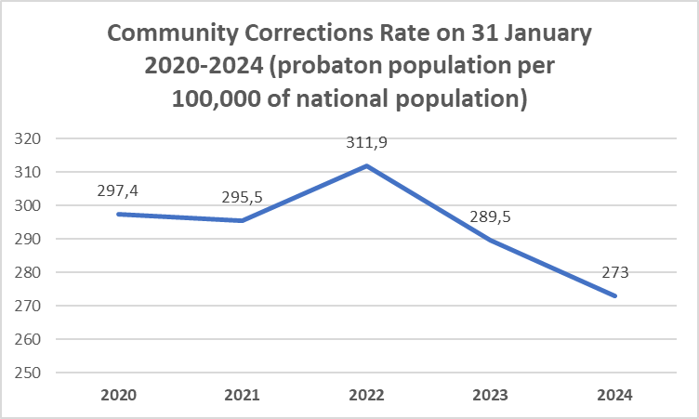

Created by: Anvars Zavackis

Number of persons under the supervision of SPS on 31 January 2024 (STOCK OF PROBATIONERS). Source: Aebi, M. F., Cid-Pozo, I., Molnar, L., & Hashimoto, Y. Z. (2024). SPACE II – 2024 – Council of Europe Annual Penal Statistics: Persons under the supervision of probation agencies. Council of Europe. https://wp.unil.ch/space/files/2025/11/space-ii_report-2024_251105.pdf
Stock of probationers (probatiion population per 100,000 of national population) in rates on 31 January 2024. Source: Aebi, M. F., Cid-Pozo, I., Molnar, L., & Hashimoto, Y. Z. (2024). SPACE II – 2024 – Council of Europe Annual Penal Statistics: Persons under the supervision of probation agencies. Council of Europe. https://wp.unil.ch/space/files/2025/11/space-ii_report-2024_251105.pdf
The number of females in absolute numbers (percentages) under the community correction (SPS ) on 31 January 2024. Source: Aebi, M. F., Cid-Pozo, I., Molnar, L., & Hashimoto, Y. Z. (2024). SPACE II – 2024 – Council of Europe Annual Penal Statistics: Persons under the supervision of probation agencies. Council of Europe. https://wp.unil.ch/space/files/2025/11/space-ii_report-2024_251105.pdf
The number of minors in absolute numbers (percentages) under the community correction (SPS ) on 31 January 2024. Source: Aebi, M. F., Cid-Pozo, I., Molnar, L., & Hashimoto, Y. Z. (2024). SPACE II – 2024 – Council of Europe Annual Penal Statistics: Persons under the supervision of probation agencies. Council of Europe. https://wp.unil.ch/space/files/2025/11/space-ii_report-2024_251105.pdf
The number of foreign individuals in absolute numbers (percentages) under the community correction (SPS ) on 31 January 2024. Source: Aebi, M. F., Cid-Pozo, I., Molnar, L., & Hashimoto, Y. Z. (2024). SPACE II – 2024 – Council of Europe Annual Penal Statistics: Persons under the supervision of probation agencies. Council of Europe. https://wp.unil.ch/space/files/2025/11/space-ii_report-2024_251105.pdf
The number of probation clients placed under probation before the sentence in absolute numbers ( percentages) under the community correction (SPS ) on 31 January 2024. Source: Aebi, M. F., Cid-Pozo, I., Molnar, L., & Hashimoto, Y. Z. (2024). SPACE II – 2024 – Council of Europe Annual Penal Statistics: Persons under the supervision of probation agencies. Council of Europe. https://wp.unil.ch/space/files/2025/11/space-ii_report-2024_251105.pdf
Prior to sentencing, parties may engage in a victim-offender mediation process facilitated by the State Probation Service; however, this process does not constitute probation supervision.
Information source: State Probation Service (Latvia), Public Annual Report 2024; the figure was calculated by summing all requests for pre-trial assessment reports received during the calendar year and is not included in this section’s “Total (percentage)” calculation. https://www.vpd.gov.lv/lv/media/2135/download?attachment
The number of probation clients placed under probation after the sentence in absolute numbers ( percentages) under the community correction (SPS ) on 31 January 2024. Source: Aebi, M. F., Cid-Pozo, I., Molnar, L., & Hashimoto, Y. Z. (2024). SPACE II – 2024 – Council of Europe Annual Penal Statistics: Persons under the supervision of probation agencies. Council of Europe. https://wp.unil.ch/space/files/2025/11/space-ii_report-2024_251105.pdf
The number of probation clients placed under probation after release from custudy in absolute numbers ( percentages) under the community correction (SPS ) on 31 January 2024. Source: Aebi, M. F., Cid-Pozo, I., Molnar, L., & Hashimoto, Y. Z. (2024). SPACE II – 2024 – Council of Europe Annual Penal Statistics: Persons under the supervision of probation agencies. Council of Europe. https://wp.unil.ch/space/files/2025/11/space-ii_report-2024_251105.pdf
Parole reports: total of 464 requests in 2024 received to evaluate eligibility of individuals for conditional release. Information source: State Probation Service (Latvia), Public Annual Report 2024; the figure was calculated by summing all requests for parole reports received during the calendar year and is not included in this section’s “Total (percentage)” calculation. https://www.vpd.gov.lv/lv/media/2135/download?attachment
Sources: Aebi, M. F., Cid-Pozo, I., Molnar, L., & Hashimoto, Y. Z. (2020, 2021, 2022, 2023, 2024). SPACE II Anual Reports 2020 –2024. Council of Europe Annual Penal Statistics: Persons under the supervision of probation agencies. Council of Europe. https://wp.unil.ch/space/space-ii/annual-reports/

