community corrections

In Philippines
Narrative Summary
[MAY 2, 2026]

Prepared by:

Danilo M. Capili
OIC-Assistant Regional Director (DOJ-PPA-Region III)

Frances F. Magnaan
Regional Director (DOJ-PPA-CAR)

Zedny C. Immatong
Doctoral Student – University of Massachusetts-Lowell

Dr. Raymund Narag
Associate Professor – Southern Illinois University
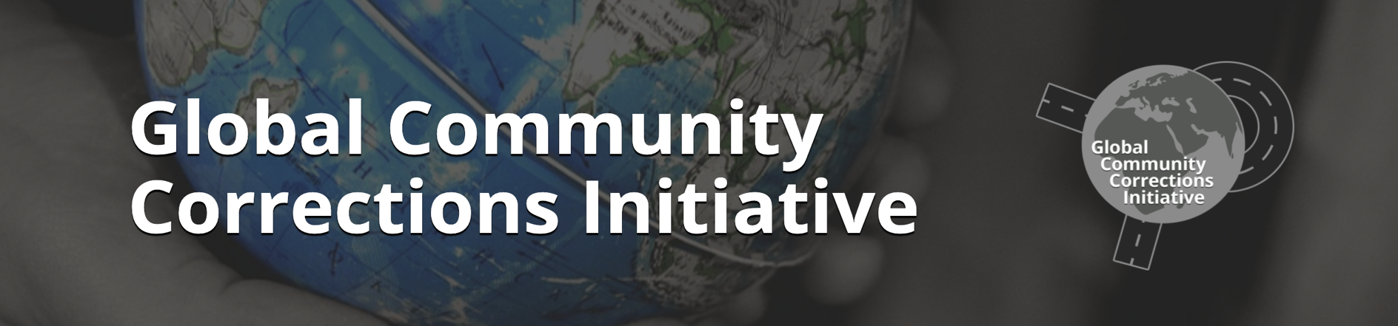
Advocate of Penology Reforms in the Philippines

Table of
Contents
ABOUT COMMUNITY CORRECTIONS IN THE PHILIPPINES 1
HISTORY OF PHILIPPINE COMMUNITY CORRECTIONS 1
OTHER LAWS RELATED TO COMMUNITY CORRECTIONS 3
FORMS OF COMMUNITY CORRECTIONS 6
CHALLENGES IN PROBATION AND PAROLE 6
1. Extremely Heavy and Unmanageable Caseload 6
2. Influx of Clients Due to Criminal Justice Policy Shifts 6
3. Declining Number of Probation Officers and High Vacancy Rates 7
4. Declining Number of Volunteer Probation Assistants 7
5. Structural and Administrative Constraints in Hiring 7
6. Inadequate Budget Allocation 8
7. Outdated Legal and Organizational Framework 8
8. Limited Resources for Modernization and Innovation 8
SUCCESS/UNIQUE INITIATIVES 10
1. Effective Community-Based Corrections and Rehabilitation 10
2. Very High Client Compliance Rates 10
3. Contribution to Crime Prevention and Justice Administration 10
4. Cost-Efficient Alternative to Incarceration 11
5. Sustained Service Delivery Despite Resource Constraints 11
COMPOSITION OF OFFENDERS SUPERVISED IN THE COMMUNITY 12
Population Distribution Trend 13
Crime Distribution Trend 14
Age Distribution Trend 16
Sex Distribution Trend 18
Educational Attainment Distribution 19
WAYS FORWARD – FUTURE OF COMMUNITY CORRECTIONS IN THE PHILIPPINES 21
BACKGROUND OF THE REFORM INITIATIVE 21
DEVELOPMENT OF THE CLASSIFICATION AND RISK ASSESSMENT TOOL (CARAT) 23
EVIDENCE-BASED REHABILITATION PROGRAMS 24
ALIGNMENT WITH INTERNATIONAL STANDARDS AND BEST PRACTICES 25
STRATEGIC DIRECTIONS FOR THE FUTURE 26
CONCLUSION 27
REFERENCES 28

ABOUT COMMUNITY CORRECTIONS IN THE PHILIPPINES

In the Philippines, there are two main community-based programs: probation and parole. Probation involves community release for offenders sentenced to six years or less, provided they meet all qualifications, with the court granting probation for a specified period. Parole, however, allows an offender to be released early after serving at least one-third of their maximum sentence, with approval from the Board of Pardon and Parole.

HISTORY OF PHILIPPINE COMMUNITY CORRECTIONS: https://probation.gov.ph/establishment-development-probation-administration/
Probation is based on the belief that offenders can reform and that rehabilitation benefits society more than punishment alone. As early as the 13th century, English courts used lenient alternatives such as clergy transfers, sentence reprieves, deportation, and release on recognizance, laying the groundwork for modern probation. Probation later became formally established in England and the United States. Certain foundational practices of probation and parole from England and the United States have been adopted in the Philippines.
Early Juvenile Probation

- 1932: Article 80 of the Revised Penal Code allowed suspension of sentence for offenders under 16 accused of grave or less grave felonies, placing them under institutional supervision. PD 603 defined minors as persons below 21 years old. Later, PD 1179 lowered the age of majority to 18.
- The Dangerous Drugs Act of 1972 (RA 6425) allowed probation and suspended sentences for first-time youth drug offenders (under 18 at the time of the offense but no older than twenty-one at the time of judgment).
- Republic Act No. 9344, as amended by RA 10630, authorized courts, upon application at any time, to place a child in conflict with the law on probation in lieu of serving a sentence, taking into account the child’s best interests.
Adult Probation Development

- 1935: Act No. 4221 established the first adult probation in the Philippines, created a Probation Office, and extended probation to first-time adult offenders aged 18 and above.
- 1937: The Supreme Court struck down Act No. 4221 as unconstitutional due to improper delegation of power and equal protection issues (see People of the Philippines vs. Vera).
- Later bills (e.g., House Bill No. 393) sought to revive it but stalled due to Martial Law.
Legislative Push and Enactment

- 1973: Efforts to establish adult probation advanced in 1973, when the Bacolod City Police Advisory Council drafted a proposed Probation Decree that incorporated earlier legislative bills and received endorsement from the Integrated Bar of the Philippines.
- 1975: Support strengthened in 1975 after NAPOLCOM recognized the need for an adult probation system following recommendations from a UN crime prevention congress. An inter-disciplinary committee conducted technical hearings, and the draft received broad approval from the justice and law enforcement sectors. The finalized decree was ultimately endorsed by key national officials and submitted to the President for enactment.
- 1976: Presidential Decree No. 968 (Probation Law of 1976) was signed into law by President Marcos, formally establishing probation nationwide.
  - BP 76 expanded probation eligibility by increasing the allowable sentence threshold for probation.
  - PD 1990 amended PD 968 and BP 76, prohibiting probation pending appeal and adding probation disqualification, with probation applied only to offenders sentenced to a maximum of six years.
  - Executive Order No. 468 revitalized the Volunteer Probation Aide Program to strengthen community involvement in crime prevention, offender treatment, and the administration of criminal justice.
  - Republic Act 10707 further amended the previous probation laws, allowing probation to be imposed during an appeal if the sentence is modified to a probationary one, amended the disqualification section, and enhanced the role of Volunteer Probation Assistants (VPAs).
Strengthening of the System

- In 1987, the Administrative Code of 1987 (Executive Order No. 292) renamed the agency the Parole and Probation Administration (PPA) and expanded its supervision of parolees.
- PPA also handles first-time minor drug offenders and supports the Voluntary Submission Program under RA 9165.
- Community-based rehabilitation expanded through the Volunteer Probation Aide Program (EO 468).
- The Recognizance Act of 2012 authorized the PPA to supervise and monitor qualified indigent accused released on recognizance.
- The PPA now plays a central role in community-based crime prevention, rehabilitation, and offender reintegration in the Philippines.

OTHER LAWS RELATED TO COMMUNITY CORRECTIONS
Act 4103 - Indeterminate Sentence Law

- It establishes a sentencing framework requiring courts to impose prison terms with both minimum and maximum periods. The minimum term allows offenders the possibility of early release, while the maximum reflects the full penalty under the law.
- It creates the Board of Pardon and Parole, tasked with evaluating prisoners’ physical, mental, and moral readiness for reintegration. Upon serving the minimum sentence, eligible inmates may be released on parole if they demonstrate good conduct and a likelihood of lawful behavior. Parolees must comply with supervision conditions, report to designated officers, and may be rearrested for violations.
- It institutionalizes structured assessment, conditional release, and oversight mechanisms to promote rehabilitation while protecting public welfare.
- It underpins community corrections by shifting part of the punishment from confinement to supervised release in the community. Through parole supervision, monitoring, and reintegration support, it aligns with modern community-based correctional goals—reducing incarceration time, encouraging rehabilitation, and involving agencies like the Parole and Probation Administration in post-release supervision. It therefore forms a legal foundation for non-custodial correctional strategies within the Philippine criminal justice practice.

Republic Act No. 10592

- Republic Act No. 10592 amends provisions of the Revised Penal Code concerning credit for preventive imprisonment and time allowances for persons deprived of liberty. It grants full or partial credit for time spent in preventive detention, subject to compliance with institutional rules, and provides for immediate release when the detention equals the maximum possible sentence.
- The law expands the mechanisms for partial extinction of criminal liability through good conduct time allowance (GCTA), study, teaching, or mentoring credits, and special time allowance for loyalty during calamities.
- By formalizing sentence reductions tied to behavior and rehabilitation efforts, the Act promotes discipline and participation in correctional programs while establishing administrative accountability in the computation of credits and allowances.
- Importantly, it indirectly strengthens community corrections by accelerating eligibility for parole, probation-related reintegration pathways, or release supervision under agencies like the PPA.
- Earlier release through earned credits reduces congestion in custodial facilities and shifts focus toward community-based supervision and rehabilitation. It reinforces behavior-based reform incentives that align with restorative correctional goals. However, it also increases the workload and responsibilities of community corrections personnel in monitoring reintegrated individuals and ensuring public safety, highlighting the need for careful implementation and transparent computation of sentence credits.

Republic Act No. 11362 - Community Service Act

- It authorizes courts to impose community service instead of imprisonment for offenses punishable by arresto menor and arresto mayor. It aims to promote restorative justice and reduce jail congestion by allowing qualified offenders to render service in the community where the offense occurred. Courts determine the duration and conditions of service, while probation officers supervise compliance and ensure accountability.
- Offenders must also undergo rehabilitative counseling with local social welfare officers and support from DSWD. Community service involves physical activities that foster civic consciousness and benefit public works or services. Noncompliance results in re-arrest and service of the original jail penalty, while successful completion leads to release. The privilege is granted only once.
- Implementation guidelines are issued by the Department of Justice (DOJ) and the Department of Social Welfare and Development (DSWD). Overall, the law integrates punishment, rehabilitation, and community participation within the criminal justice process.
- It strengthens community corrections by expanding probation officers' supervisory roles, institutionalizing non-custodial sanctions, supporting rehabilitation, and easing jail overcrowding. It aligns with restorative justice principles and reinforces probation-based interventions as frontline correctional strategies.

FORMS OF COMMUNITY CORRECTIONS

For individual information about parole and probation, check out the attached files:
- Parole and Executive Clemency Info
- Probation Info
- Probation and Parole Workflow
- Three Major Programs: Restorative Justice, Therapeutic Community, and Volunteerism
- Important Laws: Act 4103 and Presidential Decree 968

CHALLENGES IN PROBATION AND PAROLE
The Philippines continues to face challenges in implementing community-based sanctions due to resource constraints, institutional barriers, and the effects of criminal justice reforms.

1. Extremely Heavy and Unmanageable Caseload
- The PPA is experiencing an unprecedented surge in both investigation and supervision cases.
- By December 2023, the Agency handled:
  - 133,214 investigation cases
  - 162,392 supervision cases - the highest in PPA history.
- Each probation officer now handles an average of:
  - 232 investigation cases
  - 283 supervision cases
- This far exceeds the ideal caseload ratio of 1:50 recommended by the University of the Philippines–NCPAG.

2. Influx of Clients Due to Criminal Justice Policy Shifts
- The sharp increase in caseload is linked to:
  - The intensified anti-illegal drugs campaign began in 2016.
  - The Supreme Court’s adoption of the Plea Bargaining Framework in Drug Cases (2018), which lowered penalties under RA 9165 and expanded eligibility for probation and parole.
- These policy shifts significantly increased referrals to the PPA without a corresponding increase in manpower or resources.

3. Declining Number of Probation Officers and High Vacancy Rates
- Despite rising caseloads, the number of active probation officers continues to decline:
  - From 662 active officers in 2019
  - To 573 active officers by December 2023
- Vacancy rates increased from 23.02% (2019) to 31.4% (2023).
- High turnover is attributed largely to work-related stress and burnout

4. Declining Number of Volunteer Probation Assistants
- Despite the revitalization of the VPA program, the number of appointed volunteer probation assistants declined over the last decade.
- Demanding workload and meager travel allowance may be contributory to the difficulty in recruitment and retention
- The decline may also be attributed to the agency's emphasis on quality rather than quantity. In the last decade, greater emphasis has been placed on the mobilization rate rather than the number of VPAs.
- The VPA may be considered mobilized if they perform any of the following:
  - as a direct supervisor of clients not exceeding 5 at any given time.
  - as resource individuals who provide technical guidance and support, or may provide resources for client rehabilitation.
  - perform both the functions of a direct supervisor and a resource individual

5. Structural and Administrative Constraints in Hiring
- Workforce shortages were aggravated by:
  - Absence of an appointing authority for probation officers from February 2020 to October 2023.
  - Low passing rates in the probation officer selection process.
  - Low salary levels that are not commensurate with workload and job demands

6. Inadequate Budget Allocation
- The PPA receives less than ₱1 billion annually, representing only about 3% of the national corrections sector budget.
- This budget is largely sufficient only for day-to-day operations, leaving limited capacity for:
  - Office improvement and maintenance
  - Workforce training and capacity-building
  - ICT modernization and systems development

7. Outdated Legal and Organizational Framework
- The Agency continues to operate under Presidential Decree No. 968 (1976).
- Compared with other corrections agencies that have undergone modernization, the PPA has been left behind structurally and technologically, limiting its ability to adapt to evolving criminal justice and societal demands

8. Limited Resources for Modernization and Innovation
- Insufficient funding and outdated legal foundations hinder:
  - Digital transformation
  - Infrastructure development
  - Adoption of evidence-based rehabilitation and supervision tools
- This constrains the Agency’s responsiveness within a rapidly evolving justice system
9. Lack of continuity of effective programs resulting from changes in organizational leadership following political transitions such as elections and subsequent cabinet revamp/restructuring
10. Program Implementation Challenges
- Therapeutic Community
- Implemented largely in accordance with established theory and operations; however, pandemic restrictions disrupted fidelity to the program.
- Field offices adapted by using online platforms or satellite offices for clustered sessions.
- Certain behavior-shaping tools were deemed culturally inappropriate for Filipino clients.
- Severe manpower shortage: each PPO handles 200–600 cases monthly, far exceeding the ideal ratio of 1:50.
- Support staff and training are insufficient, and program forms are often difficult to complete.

- Restorative Justice Program (RJP)
  - Consistent with its theoretical framework, but irregularly implemented and conducted only when necessary.
  - When implemented, the RJP effectively restored relationships and repaired harm among stakeholders.
  - PPOs demonstrated competence but required further specialized training in mediation and restorative practices.
  - Implementation was limited by the victims’ lack of participation and by resource constraints.
  - RJP activities helped reduce recidivism and improved community acceptance of clients, though victim support mechanisms need strengthening.
- Case Classification Tool
- Found to be ineffective and outdated, failing to guide appropriate interventions.
- Indicators were too broad and inconsistently interpreted across field offices.
- The tool was discriminatory toward LGBTIQA+ clients and men. This also includes civil status since the tool assigns greater weight to individuals who are separated, divorced, or annulled.
- A new assessment instrument, the Client Assessment and Risk Assessment Tool (CARAT), is being developed as a replacement for the current instrument.
- Volunteer Probation Assistant
- VPAs are predominantly female, middle-aged, and college-educated, and they volunteer for fewer than 4 hours per week.
- Altruism and community service drive participation; personal invitations are more effective than mass recruitment drives.
- Training coverage is uneven; most receive basic or orientation training, but few undergo refresher or advanced sessions.
- VPAs play crucial roles in client supervision, counseling, and community engagement, yet they receive minimal logistical support and recognition.
- Despite challenges, VPA reports high job satisfaction (4.68/5) and a strong desire to continue volunteering.

SUCCESS/UNIQUE INITIATIVES
Through government efforts, particularly those of the Parole and Probation Administration, community-based corrections in the Philippines have achieved significant success. It continues to play a vital role in ensuring that parole and probation services are both effective and efficient, making a positive difference in communities across the Philippines.

1. Effective Community-Based Corrections and Rehabilitation

- Over the past six (6) years, the PPA has been effective in implementing community-based correction and rehabilitation programs for probationers and former persons deprived of liberty (PDLs).
- These efforts likely contributed directly to reducing recidivism and strengthening community reintegration

2. Very High Client Compliance Rates
- From 2018 to 2023, the Agency sustained an average compliance rate of 99.22% with probation and parole conditions.
- This indicates strong supervision, monitoring, and rehabilitation effectiveness across field offices nationwide

3. Contribution to Crime Prevention and Justice Administration

- Through effective supervision and rehabilitation, the PPA significantly contributed to:
  - Prevention and reduction of crime incidence
  - Overall efficiency of the criminal justice system
- The document explicitly recognizes the PPA’s role as a stabilizing component of public safety

4. Cost-Efficient Alternative to Incarceration

- The PPA contributed to the implementation of the PD 968’s goal to provide a less costly alternative to imprisonment for eligible offenders.
- In CY 2023 alone, the government saved an estimated ₱4.044 billion.
- Total cumulative savings since 1978 reached approximately ₱19.55 billion

5. Sustained Service Delivery Despite Resource Constraints

- Despite manpower shortages, heavy caseloads, and limited funding, the PPA:
  - Maintained high performance indicators
  - Continued nationwide service delivery
- This implicitly reflects organizational resilience and workforce commitment

COMPOSITION OF OFFENDERS SUPERVISED IN THE COMMUNITY
This section presents demographic and population trends among individuals under the supervision of the Parole and Probation Administration (PPA) from 2015 to 2025. The data employed to generate the figures are compiled data requested from the PPA.
Note:
Several reminders must be noted when interpreting the population and demographic trends presented in this study. Changes in the population and demographic characteristics are not entirely due to newly admitted probationers and parolees. On average, individuals under community supervision, both parolees and probationers, remain under supervision for about three to four years. As such, the same individuals may continue to be counted in the population across succeeding years. For instance, individuals aged 40 in 2018 would be counted in the 41–50 age group in 2019. Consequently, there may appear to be an increase in one age group and a decrease in another, even though the same individuals are being accounted for in subsequent years.
Major turning points in the population and crime distribution of parolees and probationers may also be influenced by external factors. In particular, the increase observed around 2017 may be associated with the government’s drug policy and the Supreme Court decision in Estipona, Jr. v. Lobrigo (G.R. No. 226679), which allowed plea bargaining for qualified drug offenders. Individuals who were subject to this policy and benefited from plea bargaining arrangements were subsequently placed under the supervision of the Parole and Probation Administration (PPA).
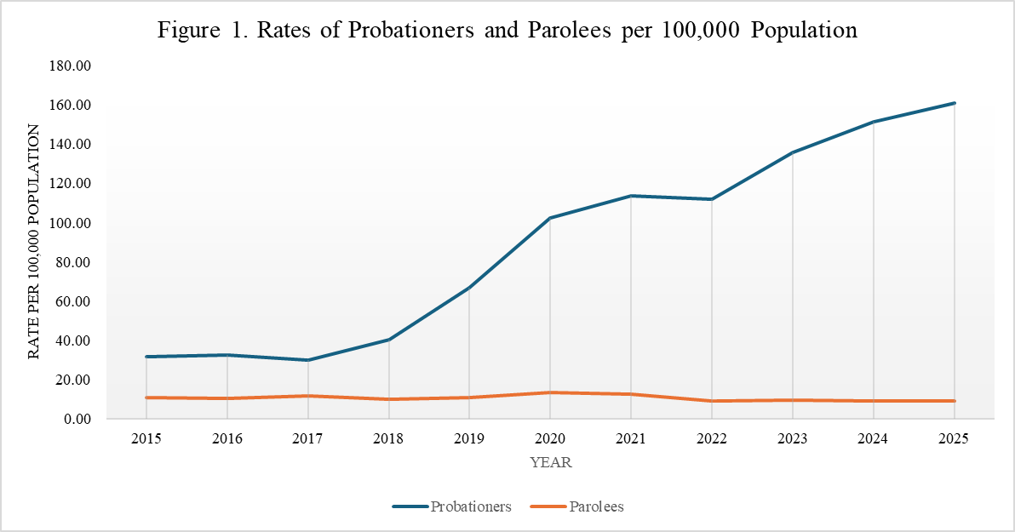
Figure 1 shows that the rate of probationers increased steadily from 2015 to 2025. A notable rise began in 2018, with the rate increasing from 29.84 per 100,000 population in 2017 to 40.31 per 100,000 in 2018, and continuing upward until 2021. A slight decline is observed in 2022, with the rate decreasing from 113.51 per 100,000 in 2021 to 111.61 per 100,000. From 2022 onward, the rate increased sharply, reaching 160.62 per 100,000 population by 2025. Overall, this represents a substantial increase in the probationer rate over the period. In contrast, the rate of parolees remained relatively stable from 2015 to 2025, with a slight overall decline over time.

Population Distribution Trend
Figure 2 shows the trend in the distribution of probationers and parolees under the supervision of the Parole and Probation Administration (PPA) from 2015 to 2025. The percentage of probationers generally increased over the period. Following a slight decline in 2017, the proportion of probationers increased in 2018 and continued to increase steadily through 2025. In contrast, the proportion of parolees exhibited the opposite trend, peaking in 2017 and gradually declining in subsequent years as the share of probationers increased. In addition to probationers and parolees, pardonees are also supervised by the PPA. However, they constitute only a small portion of the supervised population, averaging approximately 144 individuals annually from 2015 to 2025.
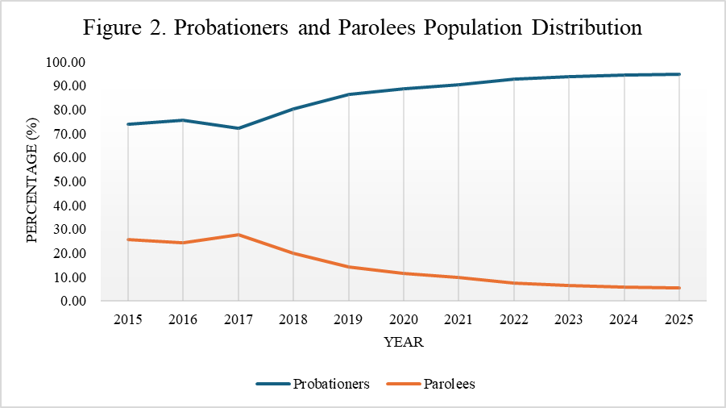

Crime Distribution Trend
Figure 3 shows the distribution of crimes committed by individuals under probation from 2015 to 2025. The offenses include drug-related crimes, crimes against persons, crimes against property, ordinance violations, and other crimes. Overall, the figure shows several fluctuations in the earlier years, followed by relatively stable trends from 2022 to 2025.

Drug-related offenses initially declined from about 30% in 2015 to around 25% in 2016 but gradually increased afterward. The proportion rose steadily from 2017 to 2020 and peaked at approximately 38% in 2021 before stabilizing at around 32–33% from 2022 to 2025. Crimes against persons accounted for about 22% of cases in 2015 and slightly declined in 2016. However, a substantial increase began in 2019, reaching nearly 40% in 2021 before stabilizing at approximately 31–32% in the following years. Crimes against property remained relatively stable throughout the period, fluctuating between roughly 15% and 19%, with a slight decline observed in 2019. Violations of local ordinances comprised only a small proportion of cases. These offenses were nearly absent before 2019 but showed a slight increase afterward, stabilizing at around 2% from 2019 to 2025. The “Others” category showed the highest early fluctuation, peaking at approximately 40% in 2016 before declining sharply to around 16–17% in 2019 and stabilizing at about 18–19% in later years.

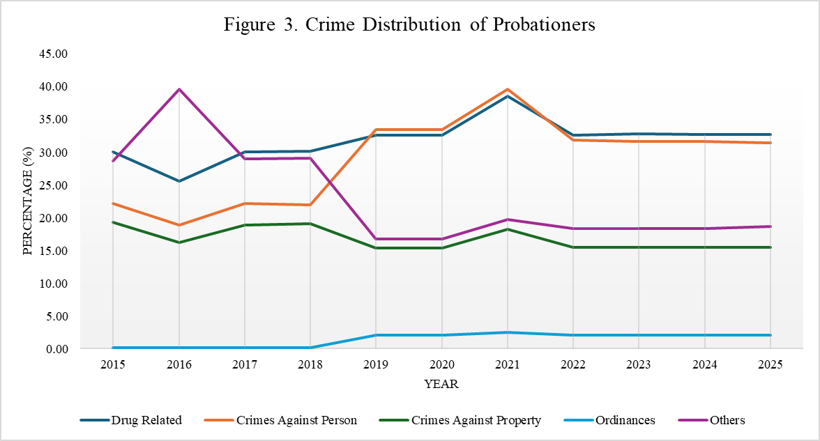

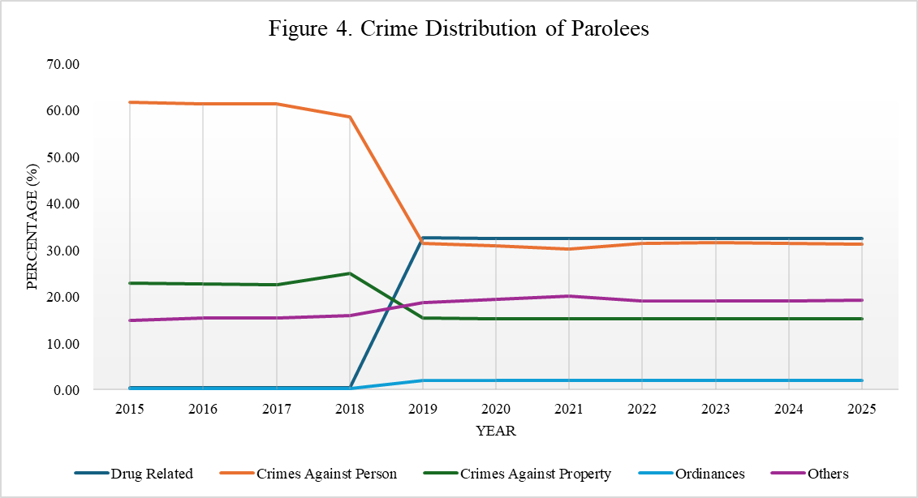
Figure 4 presents the distribution of crimes committed by parolees from 2015 to 2025. Specifically, 2019 shows a key turning point in the distribution of crime among parolees. Drug-related offenses, which accounted for less than 1% of cases from 2015 to 2018, increased sharply to approximately 32.6% in 2019 and remained relatively stable thereafter. Conversely, crimes against persons declined substantially from about 58.6% in 2018 to around 31.5% in 2019, representing a decrease of approximately 27 percentage points. Crimes against property also declined during the same period, dropping from about 24.9% in 2018 to roughly 15.3% in 2019. Violations of local ordinances showed a slight increase beginning in 2019, rising to about 2% and remaining stable through 2025. Similarly, offenses categorized as “Others” increased from approximately 16% before 2019 to about 19–20% in the succeeding years. Overall, the distribution of crimes among parolees remained relatively stable from 2021 to 2025.

Age Distribution Trend
Figure 5 presents the age distribution of probationers under the supervision of the Parole and Probation Administration (PPA). Individuals aged below 20 (but at least 18 years old) and those aged 61 and above consistently represent the smallest proportions of probationers. From 2015 to 2018, the majority of probationers were aged 21-30, accounting for approximately 41-42% of the population, followed by those aged 31-40 at around 31-32%. However, a notable shift occurred in 2019, when the proportion of individuals aged 21-30 declined sharply from about 42% to roughly 22%, while the proportion of those aged 31-40 decreased slightly to around 29%.
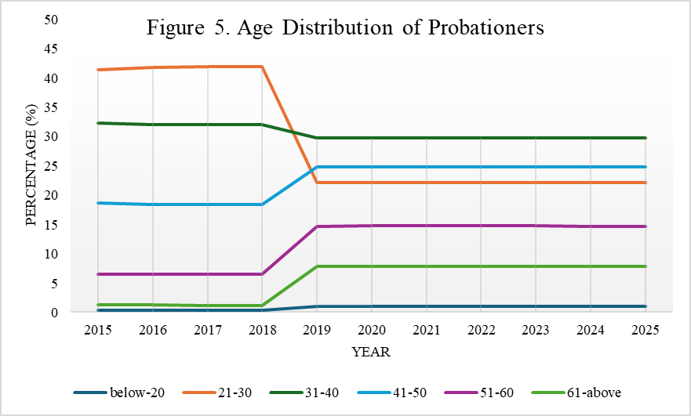

Similarly, Figure 6 shows that individuals aged below 20 (but at least 18 years old) consistently represent the smallest proportion of the parolee population throughout the period. From 2015 to 2025, parolees aged 31-40 comprised the largest share of the population, accounting for approximately 44-46%. However, this proportion declined sharply in 2019 to about 30% and continued to gradually decrease in the succeeding years. At the same time, the proportion of parolees aged 41–50 increased significantly in 2019, from roughly 15% to about 25%, showing an inverse pattern compared with the 21–30 age group. The share of individuals aged 21–30 declined from approximately 31% in 2018 to around 22% in 2019 and remained relatively stable thereafter. The proportion of parolees aged 61 and above increased noticeably beginning in 2019 and rose further in 2023, reaching approximately 13% before stabilizing in the later years.
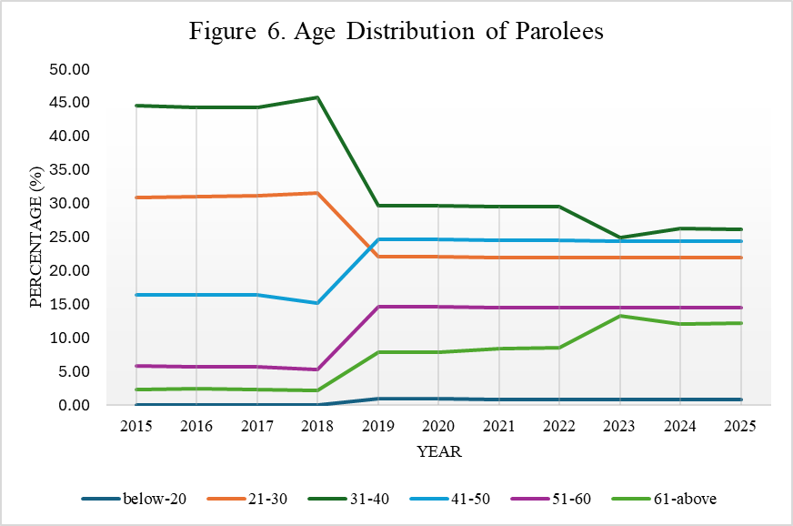

Sex Distribution Trend
Figures 7 and 8 show the sex distribution of probationers and parolees under supervision. In both groups, males constitute the majority of individuals under supervision. Among probationers, males consistently account for approximately 88-89% of the population throughout the period, while females account for approximately 10-11%. This distribution remains relatively stable from 2015 to 2025.

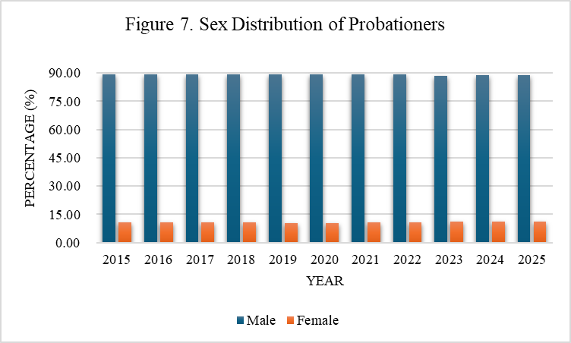
A similar pattern is observed among parolees, where males dominate the population. However, a slight decline in the proportion of male parolees is observed beginning in 2019, decreasing from about 97-98% in earlier years to approximately 89-90% thereafter. Correspondingly, the proportion of female parolees increased from roughly 2% between 2015 and 2018 to about 10% beginning in 2019 and remained stable through 2025.

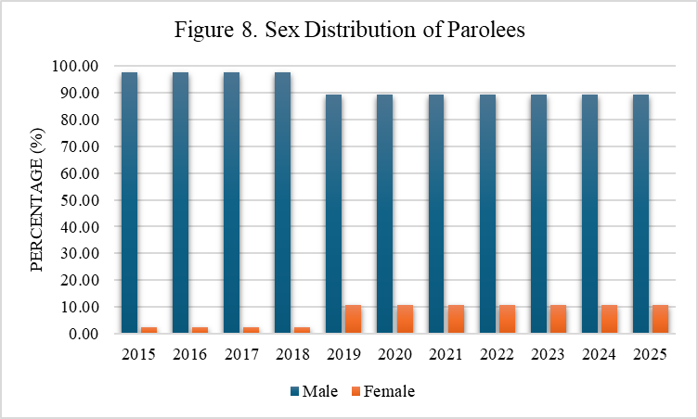

Educational Attainment Distribution
Figures 9 and 10 present the educational attainment distribution of probationers and parolees from 2015 to 2025. In both groups, the majority of individuals have either an elementary or a high school education. Among probationers, elementary graduates and undergraduates account for approximately 39-40% of the population, while high school graduates and undergraduates account for approximately 36–39%. A similar pattern is observed among parolees. Elementary graduates and undergraduates comprise about 34-40% of the population, followed by high school graduates and undergraduates at approximately 30-39%. College graduates and undergraduates account for a smaller proportion, generally ranging from about 13–19%, while individuals with vocational or postgraduate education represent roughly 3-4% of the population. The smallest group in both populations consists of individuals with no formal schooling. However, a noticeable increase in this category is observed beginning in 2019, with the proportion rising from about 1-2% in earlier years to approximately 3-4% thereafter.

WAYS FORWARD – FUTURE OF COMMUNITY CORRECTIONS IN THE PHILIPPINES
The Parole and Probation Administration (PPA) plays a crucial role in the Philippine criminal justice system by advancing community-based rehabilitation and supporting the reintegration of offenders into society. Over the years, the Agency has continuously refined its supervision strategies and intervention programs to ensure that they are responsive to the evolving needs of its clients and consistent with emerging global standards in community corrections.
A significant milestone in this effort was the completion of the Impact Assessment Study on the rehabilitation programs of the PPA, conducted with the assistance of the University of the Philippines – National College of Public Administration and Governance (UP–NCPAG). The study examined the effectiveness of the Agency’s rehabilitation interventions and assessed their impact on the lives of probationers, parolees, and pardonees, including those who have successfully completed their period of supervision. It also evaluated the efficiency and effectiveness of field offices in implementing these programs.
The findings of this study provide an important evidence base for strengthening existing interventions and for guiding the future direction of community-based rehabilitation in the Philippines. Drawing from these findings, this paper outlines key strategic directions for the Parole and Probation Administration as it continues to enhance evidence-based supervision, strengthen rehabilitation programs, and align its practices with international standards in corrections and offender reform.

BACKGROUND OF THE REFORM INITIATIVE
In recent years, the PPA has undertaken significant reforms aimed at improving the quality and effectiveness of probation and parole supervision. These reforms were undertaken through collaborative efforts involving academic experts and international partners, most notably through the assistance of Dr. Raymund Narag and the United Nations Office on Drugs and Crime (UNODC).
Initial discussions between the PPA and representatives of the UNODC focused on strengthening cooperation in advancing community-based corrections in the Philippines. These discussions eventually led to the introduction of the training program on the Principles of Effective Probation and Parole Supervision for PPA personnel. The training, which involved senior officials and field practitioners of the Agency, served as the foundation for a broader reform initiative that emphasized evidence-based approaches to offender supervision.
Following the completion of the training, technical working groups composed of experienced probation and parole officers were formed to develop improved systems for case classification, documentation, programming, and supervision.
These reform efforts are implemented within the broader operational framework of the Principles of Effective Probation and Parole Investigation and Supervision (PEPPIS). PEPPIS serves as the Agency’s guiding framework for professional practice, emphasizing structured investigation, evidence-based supervision, and client-centered interventions. Through PEPPIS, probation and parole officers are encouraged to apply validated assessment tools, maintain structured case documentation, and implement programs that directly address criminogenic risks and needs. The integration of CARAT and the Agency’s rehabilitation programs within the PEPPIS framework enhances consistency, accountability, and professional standards in community-based corrections in the Philippines. These groups worked closely with Dr. Narag and other experts to design tools and frameworks that reflect contemporary criminological research, particularly the principles of the Risk–Need–Responsivity (RNR) model.
The development process was supported by international partners, including the UNODC and the United Nations Asia and Far East Institute for the Prevention of Crime and the Treatment of Offenders (UNAFEI). A pilot implementation of the newly developed tools and programs was conducted in selected regions across the country, allowing the Agency to refine its systems before broader implementation.

DEVELOPMENT OF THE CLASSIFICATION AND RISK ASSESSMENT TOOL (CARAT)
One of the most important outcomes of this reform initiative is the development of the Classification and Risk Assessment Tool (CARAT). The CARAT was designed to provide probation and parole officers with a systematic and evidence-based method for assessing the criminogenic risks and needs of individuals under community supervision.
The use of structured risk assessment instruments is widely recognized in contemporary correctional practice as an essential component of effective offender management. By identifying the specific factors that contribute to criminal behavior, supervision strategies can be tailored to address the underlying causes of offending and to allocate resources where they are most needed.
The CARAT enables officers to classify clients by risk level and identify key criminogenic needs that must be addressed through supervision and intervention. The development of the tool followed a careful, deliberate process that included consultations with subject-matter experts, pilot testing in selected field offices, and continuous technical guidance from Dr. Raymund Narag.
Particular emphasis was placed on ensuring both the reliability and validity of the instrument. Reliability was strengthened through standardized scoring procedures and clearly defined indicators that enable different officers to arrive at consistent assessments. Validity, on the other hand, was supported by the incorporation of empirically established criminogenic risk factors and by the testing of the testing during pilot implementation.
Through the CARAT, the PPA has taken an important step toward institutionalizing evidence-based decision-making in probation and parole supervision. The tool allows officers to match the intensity of supervision and the type of intervention to each client's assessed level of risk and need, thereby improving both the effectiveness and fairness of the supervision process.

LINKING CARAT TO THE RISK–NEED–RESPONSIVITY (RNR) MODEL
The design and application of the CARAT are closely aligned with the Risk–Need–Responsivity (RNR) model, which is widely recognized in contemporary criminology as one of the most effective frameworks for reducing recidivism. The RNR model emphasizes three core principles: the risk principle, which states that the intensity of supervision should correspond to the offender’s level of risk; the need principle, which focuses interventions on criminogenic needs or dynamic factors that contribute to offending; and the responsivity principle, which highlights the importance of tailoring interventions to the learning style, motivation, and circumstances of each client.
Within this framework, the CARAT operationalizes the risk and need components of the RNR model by providing probation and parole officers with a structured means of identifying criminogenic risk factors and classifying clients according to their supervision requirements. This structured assessment ensures that higher-risk clients receive more intensive supervision and targeted interventions, while lower-risk clients are managed in ways that avoid unnecessary over-supervision. By grounding supervision decisions in the RNR framework, the PPA strengthens its ability to allocate resources efficiently and implement interventions that are empirically supported to reduce reoffending.

EVIDENCE-BASED REHABILITATION PROGRAMS
Complementing the CARAT are several intervention programs designed to address the specific criminogenic needs of clients under supervision. These programs: Hulagpos, I‑CARE, and the Livelihood and Employment Access Program (LEAP) represent the Agency’s efforts to translate risk assessment findings into concrete rehabilitation strategies.
Hulagpos: Breaking Free from Drugs
The Hulagpos Program focuses on addressing substance abuse among clients under community supervision. Drug dependency remains a significant factor in many cases handled by the PPA, and addressing this issue is essential to reducing the likelihood of reoffending.
Through structured activities, guided reflection, and behavioral interventions, the program assists participants in understanding the consequences of substance abuse and in developing the motivation and skills necessary to maintain a drug‑free lifestyle. The program also encourages clients to rebuild positive routines and strengthen support systems that can sustain long‑term recovery.
I‑CARE Program
The I‑CARE Program – standing for I Am Committed, Accountable, Responsible, and Empowered – is designed to address antisocial attitudes and behavioral patterns among clients. Such patterns are widely recognized in criminological research as among the strongest predictors of recidivism.
Through facilitated sessions, participants are encouraged to reflect on their actions, recognize the impact of their behavior on others, and develop more responsible decision‑making practices. The program promotes accountability, emotional regulation, and the development of pro‑social values that support successful reintegration into the community.
Livelihood and Employment Access Program (LEAP)
The Livelihood and Employment Access Program (LEAP) addresses the economic dimensions of reintegration. Stable employment and sustainable livelihood opportunities are widely recognized as important protective factors that reduce the likelihood of reoffending.
Through LEAP, clients are provided access to livelihood training, employment opportunities, and partnerships with government agencies, local governments, and community organizations. By strengthening their economic stability and employability, the program helps clients rebuild their lives and become productive members of society.

ALIGNMENT WITH INTERNATIONAL STANDARDS AND BEST PRACTICES
The continuing development of these tools and programs reflects the PPA’s commitment to aligning its practices with internationally recognized standards in correctional rehabilitation.
International frameworks such as the United Nations Standard Minimum Rules for Non‑Custodial Measures (Tokyo Rules), the United Nations Standard Minimum Rules for the Treatment of Prisoners (Mandela Rules), and the United Nations Rules for the Treatment of Women Prisoners and Non‑Custodial Measures for Women Offenders (Bangkok Rules) emphasize the importance of individualized case management, evidence‑based programming, and community‑based reintegration.
By developing scientifically informed assessment tools such as the CARAT and implementing targeted intervention programs like Hulagpos, I‑CARE, and LEAP, the PPA is strengthening its capacity to deliver rehabilitation services that are both humane and effective. These initiatives demonstrate the Agency’s commitment to keeping pace with contemporary developments in correctional practice and to ensuring that its programs contribute meaningfully to the reduction of recidivism.

STRATEGIC DIRECTIONS FOR THE FUTURE
Building on the results of the Impact Assessment Study and the lessons learned from pilot implementation, several strategic directions may guide the future development of the Agency:
- Institutionalization of the CARAT as the standard risk assessment tool for probation and parole supervision across all field offices.
- Nationwide implementation of evidence‑based intervention programs, including Hulagpos, I‑CARE, and LEAP.
- Continuous professional development of probation and parole officers to strengthen their competencies in evidence‑based supervision and rehabilitation.
- Strengthening partnerships with academic institutions, international organizations, and community stakeholders to support research, innovation, and program development.
- Sustained monitoring and evaluation of programs to ensure that interventions remain responsive, effective, and aligned with evolving standards in community corrections.

CONCLUSION
The Parole and Probation Administration stands at an important stage in its institutional development. The completion of the Impact Assessment Study, the development of the CARAT, and the introduction of targeted rehabilitation programs collectively represent significant progress in strengthening community-based corrections in the Philippines.
As the Agency moves forward, continued commitment to evidence-based practice, professional development, and international collaboration will be essential. The integration of scientifically grounded assessment tools such as the CARAT, the implementation of targeted rehabilitation programs, and the institutionalization of PEPPIS collectively signal a new stage in the development of community-based corrections in the Philippines.
Looking ahead, the Parole and Probation Administration is well-positioned to contribute significantly to broader reform of the Philippine correctional system. By strengthening community-based supervision, promoting rehabilitation rather than purely punitive approaches, and aligning its practices with internationally recognized standards, the Agency helps create pathways for offenders to rebuild their lives while enhancing public safety. In this way, the continued development of evidence-based probation and parole practices will not only support the successful reintegration of clients but will also play an important role in shaping a more humane, effective, and forward-looking system of community corrections in the Philippines.

REFERENCES
Administrative Code of 1987, Executive Order No. 292 (Philippines).
Amending Certain Provisions of Chapter Three, Title Eight Of Presidential Decree Numbered Six Hundred and Three Otherwise Known as The Child And Youth Welfare Code and For Other Purposes, Presidential Decree No. 1179 (1977) (Philippines).
An Act Allowing Persons Deprived of Liberty to Earn Time Allowance Through Good Conduct and Other Means, Republic Act No. 10592 (2013).
An Act Strengthening the Juvenile Justice System in the Philippines, Republic Act No. 10630 (2013).
An Act Strengthening the Probation System in the Philippines, Republic Act No. 10707 (2015).
Center for Leadership, Citizenship and Democracy (CLCD-NCPAG). (2023). Impact Assessment of the Rehabilitation Program of the Parole and Probation Administration [Report]. University of the Philippines-Diliman
Community Service Act, Republic Act No. 11362 (2019).
Comprehensive Dangerous Drugs Act of 2022, Republic Act No. 9165 (2002).
Dangerous Drugs Act of 1972, Republic Act No. 6425 (1972).
Estipona, Jr. v. Lobrigo, G.R. No. 226679, August 15, 2017.
Indeterminate Sentence Law, Act No. 4103 (1933).
Juvenile Justice and Welfare Act of 2006, Republic Act No. 9344 (2006).
Parole and Probation Administration (2015-2025). Profile Clients. [Unpublished internal document]. Department of Justice, Republic of the Philippines.

Parole and Probation Administration. (2017). FAQ on Probation. Department of Justice, Republic of the Philippines. https://probation.gov.ph/wp-content/uploads/2017/02/FAQ_Probation.pdf

Parole and Probation Administration. (2017). Parole and Executive Clemency. Department of Justice, Republic of the Philippines. https://probation.gov.ph/wp-content/uploads/2017/02/FAQ_Parole.pdf
People v. Vera, G.R. No. L-45685, November 16, 1937.
Probation Law of 1976, Presidential Decree No. 968 (1976).
Recognizance Act of 2012, Republic Act No. 10389 (2013).
The Child and Youth Welfare Code, Presidential Decree No. 603 (1974).

Except for Figure 1, all figures are presented as percentage distributions. These reflect the composition of individuals under supervision and do not indicate changes in overall prevalence increased or population-based rates
Other crimes include crimes against public interest, chastity, security, honor, special laws, public officer, ordinance, public morals, public order, and multiple crimes. Special laws are not independently shown because this category is only separated in the category in 2018.
Website: https://ncpag.upd.edu.ph/
Other references are internal reports from Parole and Probation Administration personally requested by the authors.

